Tenda F3--How to Setup port forwarding

Step 1: Login the homepage.

- Open a browser then type “192.168.0.1” into the Address Bar, press Enter. Then enter the password of this page. Tap “Login”.

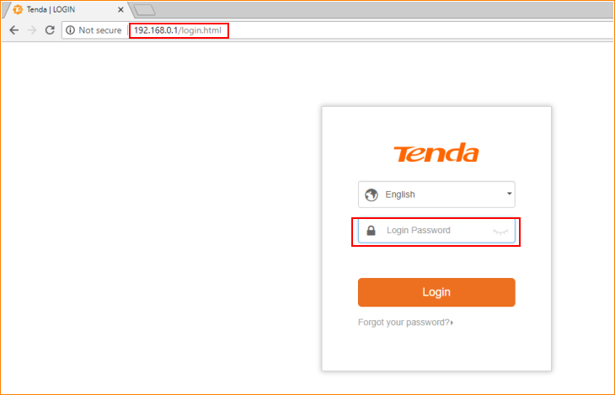

Note: The default password is shown on the bottom of the router. If you have changed it and you also forgot it, see “Forget your password?” below the “Login” button.

- Then the interface will turn into the homepage, tap “Advanced”, you can see “Port Forwarding” option in this page.

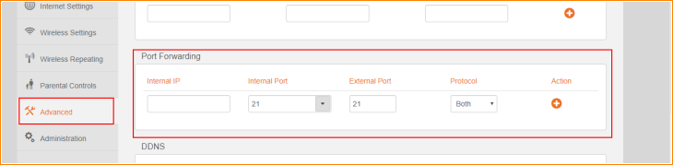

Step 2: Configure Port Forwarding

- Find "Static IP", bind an IP address with the MAC address of the mapping device, to fix an IP with this device. To avoid IP changing leading to client fail connection.

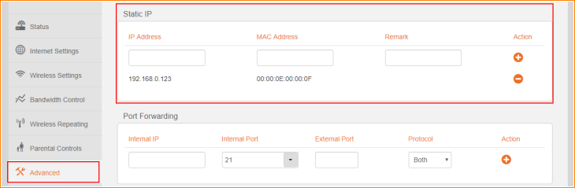

- Fill the IP address you bind in “1”, The port number that the internal network port needs to fill is opened by the mapped device, The port number of exterior network port you filled in can be same with the port number of the internal network port, you also can fill in different port number on the exterior network port, then click the "+" add, click "OK" button to save all settings

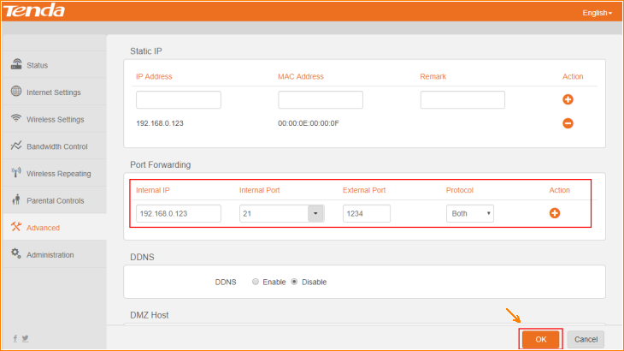

- Then you can see the result of port forwarding.

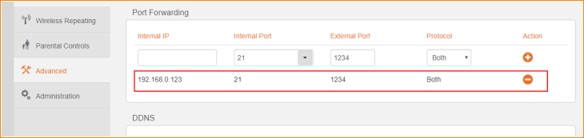

- After successful setup, access method: access to equipment at the lower end of the router is accessed through mapped intranet IP and ports; device accesses from external networks (other networks) are accessed through the IP and extranet ports of the router WAN port.

NOTE: Note: Set the Port Forwarding condition is that WAN port IP of the router is to obtain public IP, if you do not know whether your WAN port IP is public or private, please ask your ISP to check it.

